LIVING ENVIRONMENT

SYLLABUS

2020-2021



[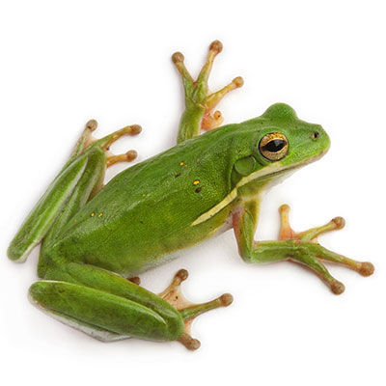](https://www.google.com/url?sa=i&rct=j&q=&esrc=s&source=images&cd=&cad=rja&uact=8&ved=0ahUKEwivgfnj7MXOAhVEgx4KHWSQByMQjRwIBw&url=http://www.petsolutions.com/C/Live-Frogs/I/Green-Tree-Frog.aspx&bvm=bv.129759880,d.dmo&psig=AFQjCNEwixbfy5pDaOXyPm4yJVJTMEczfw&ust=1471433906087652)

**Mrs. Lathrop**

**tlathrop@tbafcs.org**

**676-8000 ext 3214**

**COURSE DESCRIPTION**

**Biology is the study of all things pertaining to life. Students taking Living Environment will be introduced to the basic topics of biology including, but not limited to: Ecology, Cellular Biology, Genetics, and Human Body Systems. The content of this course will be covered in in a variety of formats based on inquiry and hands on learning. There is also a Laboratory component to this course. The intention of this course is to give the student a better understanding and appreciation for the life sciences as well as help each student develop inquiry skills that allow them to think scientifically.**

**Classroom Hygiene Responsibilities**

**Do not touch other students ever! Maintain social distancing at all times. Do not share materials or papers!**

**Wash or sanitize your hands when you enter and before leaving the room.**

**Do not touch your face.**

**All students MUST wear a face mask at all times except when seated. If you get up for any reason put on your face mask.**

**STUDENT EXPECTATIONS**

**RESPONSIBILITY**

**HONESTY**

**PRESENCE**

**RESPECT**

***DON’T CHEAT*, it will only *HURT YOU*! This includes sharing answers online!**

***DO NOT LIE*!**

**If someone cannot trust your word, there is nothing else that can be trusted either.**

***Respect Your Peers*: consider your words and actions carefully – keep them kind.**

***Respect Your Teachers*: I’m here to help you.**

***Respect Yourself*: Don’t settle for less… Only you can push yourself all the way to success.**

***SHOW UP*! you can’t learn when you are not here. That includes online days. Also, be present in *MIND*, don’t day- dream. *PARTICIPATE* in class, ask questions so you may learn.**

**Your presence will greatly affect your learning.**

**Even if you are in school or online, be on time to class. Be prepared with all materials every day. Complete and turn in your work ON TIME.**

**ALWAYS DO WHAT IS RIGHT!**

**TEACHING PHILOSOPHY**

**It is my belief that each student should be awarded the same opportunity to succeed as**

**any other student. It is my job to provide each student with the knowledge and resources**

**they need to succeed in this course, and to encourage each student to reach their full potential.**

**However, students will only be successful if they put forth the effort and participate fully in**

**the classroom activities each day.**



[](http://www.google.com/url?sa=i&rct=j&q=&esrc=s&source=images&cd=&cad=rja&uact=8&ved=0CAcQjRxqFQoTCK7QiYSt-8YCFYnQgAodY6UDrg&url=http://www.clipartpanda.com/clipart_images/brain-clip-art-21568722&ei=Wim2Va67I4mhgwTjyo7wCg&psig=AFQjCNERf0vYyaE1HZVvlksyYs-gIt1OAA&ust=1438087892584886)

**COURSE WORK: In person and Online**

|  |  |
| --- | --- |
| **CLASSWORK & ASSIGNMENTS** | Students will be assigned homework regularly. Homework is meant to reinforce the material being learned in class. Homework may consist of practice, finishing unfinished class work, working on class projects, reading or studying. All homework is due on the assigned date. **If an assignment is not completed by the assigned date a grade of ZERO will be recorded for that assignment *until that assignment is complete*. You will also only be able to hand in late assignments if we are still in that topic.**  **Check the Calendar in TEAMS often. KNOW WHEN ASSIGNMENTS ARE DUE!** |
| **EXAMS** | Tests and quizzes will be given to assess student’s knowledge of each concept or topic that is studied over no more than a two-week period. If a student pays attention, does their homework and labs; they will have practiced all of the concepts, for an exam, multiple times before the test  **Be sure to ask questions & Seek Help BEFORE the exam. DO the REVIEWS and STUDY!** |
| **LABORATORY** | **As of now, ALL STUDENTS *ARE* *SCHEDULED* TO TAKE THE REGENTS EXAM IN JUNE.** New York State mandates that to sit for the Regents Exam each student receive a minimum of 1200 minutes of laboratory activities and submit **satisfactory** reports for each lab exercise that is completed**.** |
| **ATTENDANCE &**  **MAKE-UP WORK** | It is the expectation that students strive for perfect attendance. If a student is absent, it is **his or her *responsibility*** to see the teacher or email for make-up work. **Makeup work must be completed by the date the teacher assigns.** |

**GRADING POLICY**

The grading system in this class will be based on a point system. Each item of work will be worth a predetermined number of points. All points will be summed to receive a total number of points possible and earned. Each area of work will then be ***weighted*** accordingly to receive a final percentage. Quarter grades will be determined as follows:

|  |  |
| --- | --- |
| **Quarter Grade Determination** | |
| **Tests & Quizzes**  **Class-work & Assignments**  **Laboratory Exercises** | **50 %**  **30 %**  **20 %** |
|  | |

***\*The student and parent(s) will be able to access grades through the Power-School portal at any time throughout the year.*** *Please understand that each day the student grade may change based on that days effort by the student. Graded assignments will be updated as quickly as possible, but some assignments or exams may take several days to grade and be recorded in Power-School.*

|  |  |
| --- | --- |
| **Course Grade Determination** | |
| **Quarter 1**  **Quarter 2**  **Quarter 3**  **Quarter 4**  **Regents Exam (Final)** | **20 %**  **20 %**  **20 %**  **20 %**  **20 %** |
|  | |

**HW - 30%**

**LAB - 20%**

**20%**

**20%**

**20%**

**20%**

**TESTS - 50%**

**20%**

**CLASSROOM MANAGEMENT**

It is my job, as a teacher, to maintain an environment in which all students can learn comfortably. Therefore, disruptive, inappropriate, and disrespectful behaviors ***WILL NOT*** be tolerated. Should a student fail to meet one of the above expectations, there will be consequences.

**\*Should a first or second offense be deemed severe enough by the teacher, immediate referral to the office will be made.**

**\*The student and parent/ guardian should be familiar will all school policies and guidelines as stated in the student handbook.**

**\*Students must follow social Distancing guidelines and wear appropriate face masks following school guidelines and**

**Warning will be given and I will discuss the issue with the student.**

**1st**

**Teacher Detention Parent or Guardian will be contacted.**

**2nd**

**Discipline Referral to Office. Parent or Guardian will be contacted.**

**3rd**

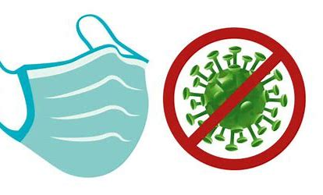

**COURSE OUTLINE**

*The following is an outline of the topics that we will cover throughout the year. The teacher retains the right to change it at any time without notice.*





* Mendelian Genetics & Heredity
* Molecular Genetics – DNA to Proteins
* Organism Body Systems
* Evolution & Taxonomy
* Principles of Ecology
* Regents Review

**Semester 2**

**Semester 1**

* What is Biology & Scientific Method
* Chemistry of Life
* Macromolecules & Enzymes
* Cell Structures
* Cell Transport & Energy
* Cell Growth and Reproduction

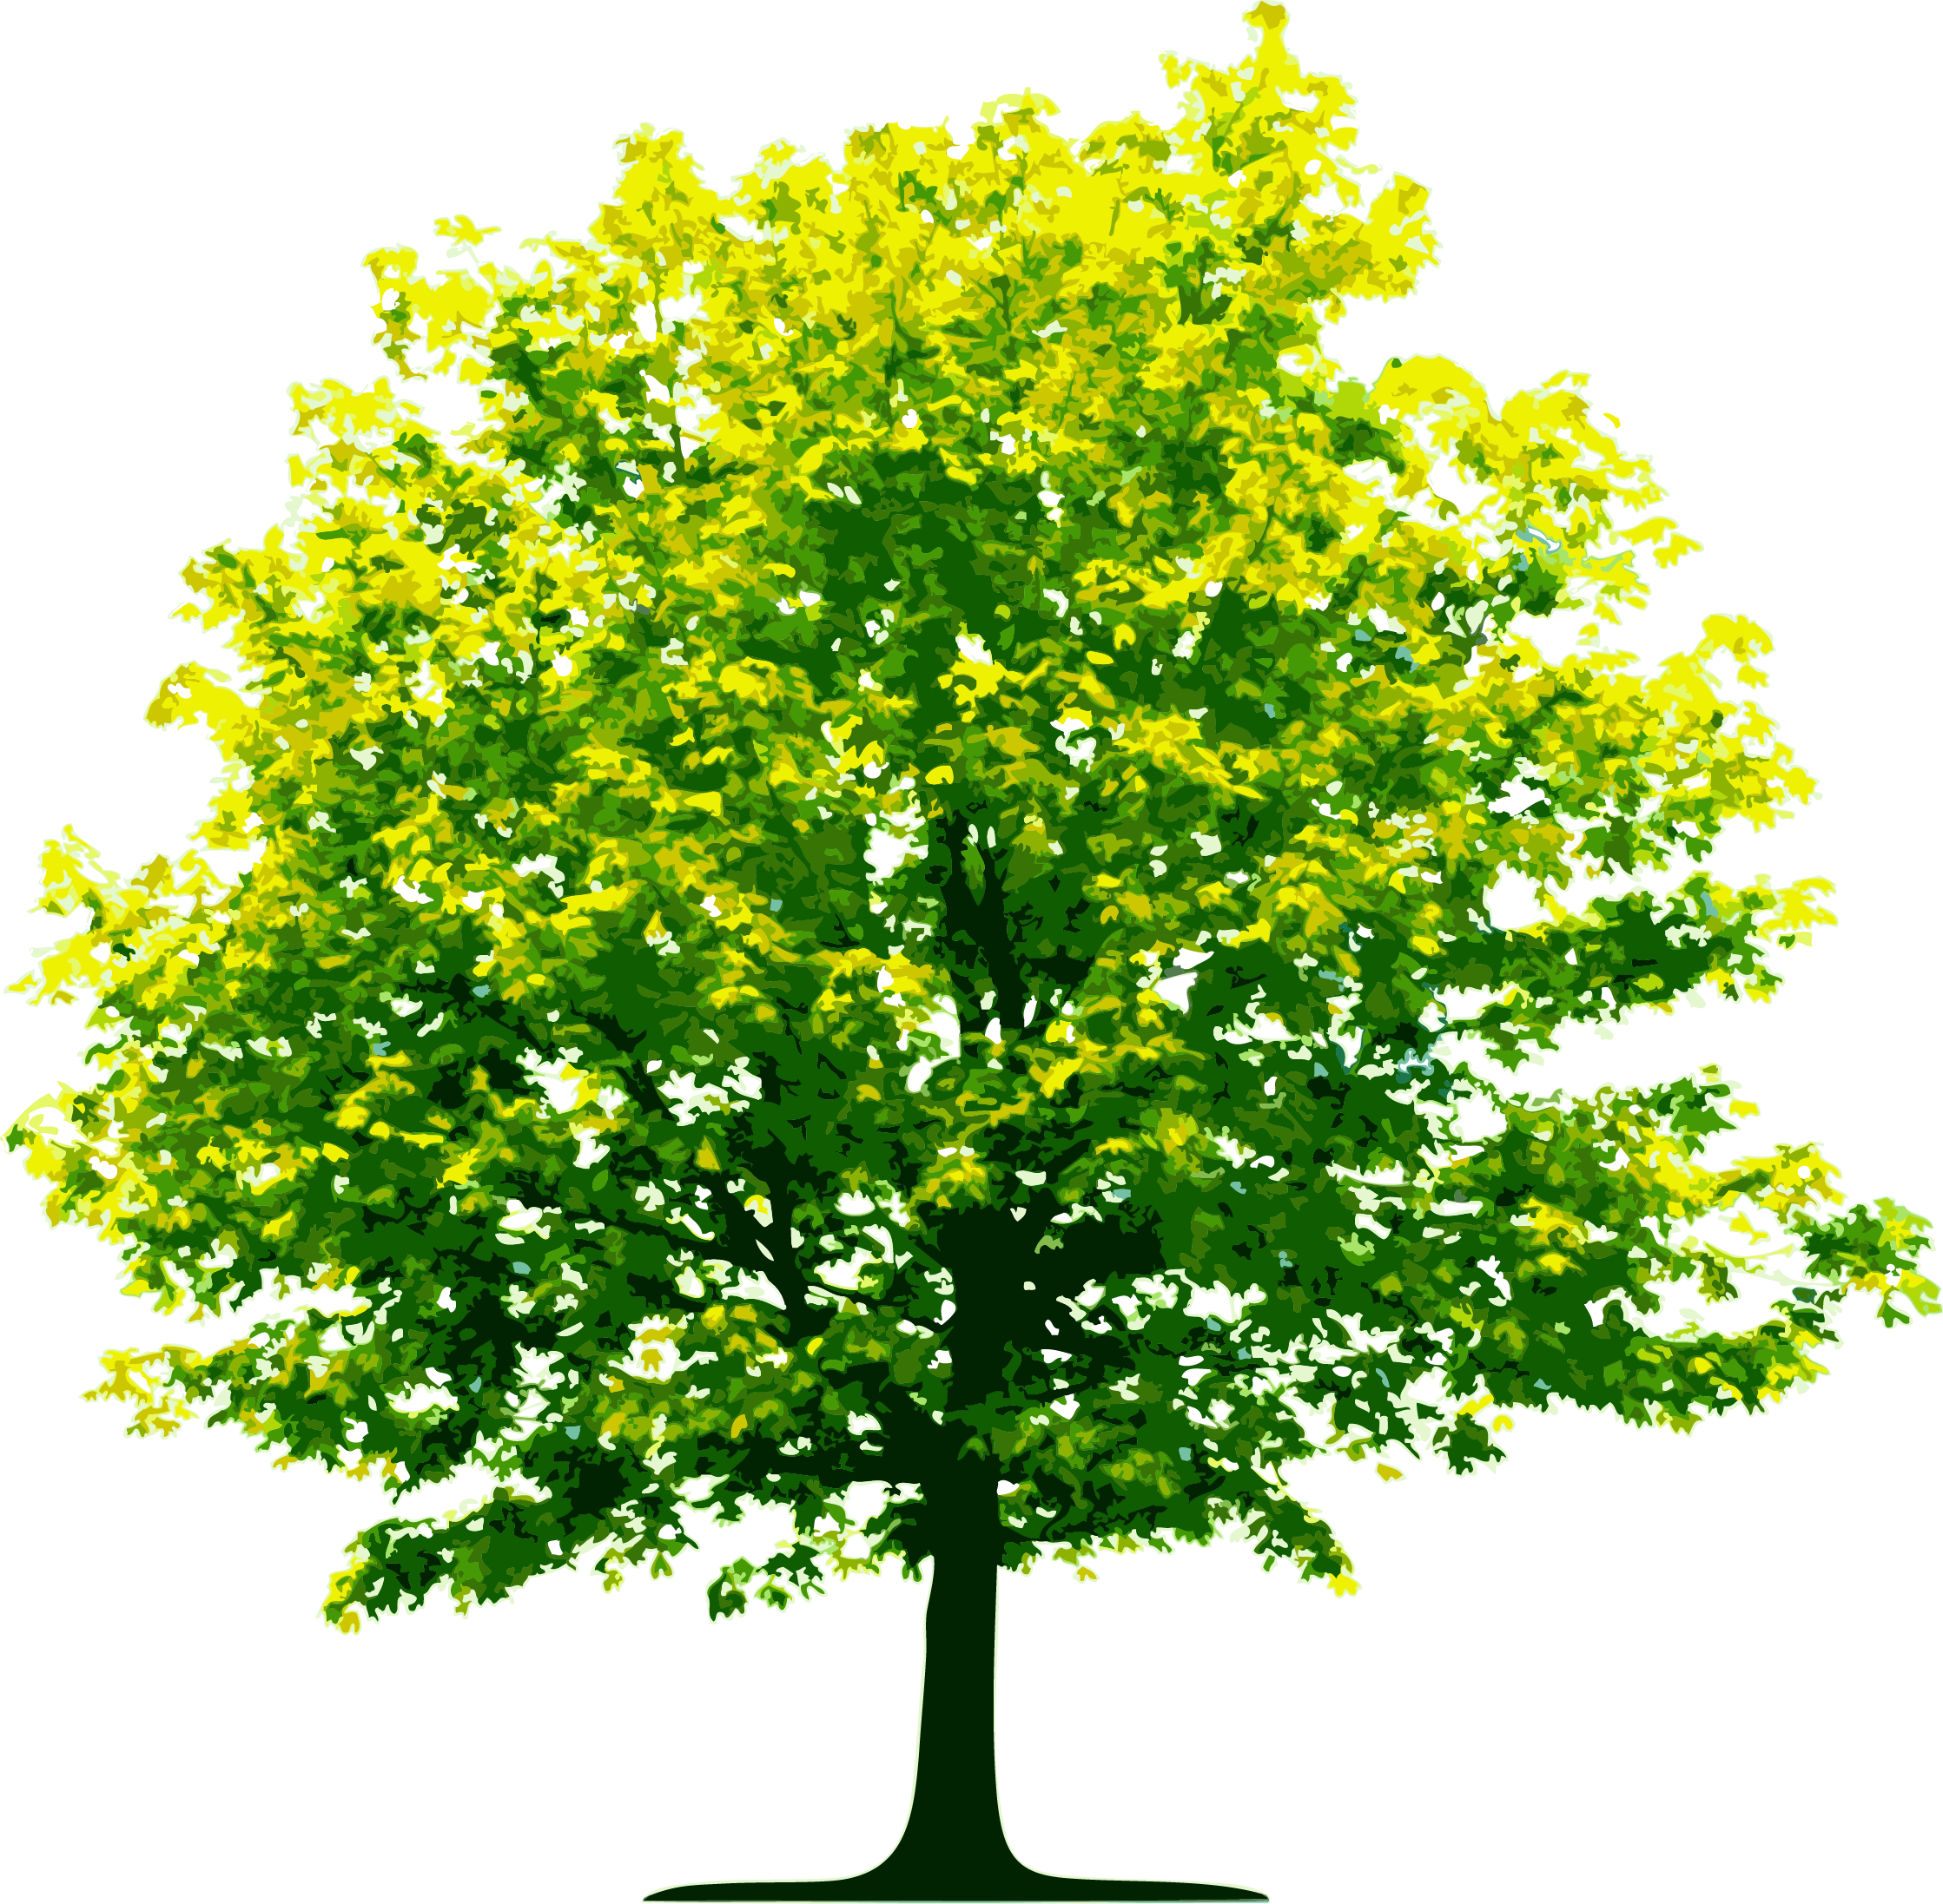





Dear Students and Parents,

This year I am setting up the *Remind* APP to stay in communication with students and parents. I can send reminders out about HW, Tests, school events ect. I encourage **BOTH** parents and students to add my Biology classroom on this app.

Simply download the Remind app and use the link:

<https://www.remind.com/join/biologytba>